**WITH NOISE AND WITHOUT FILTER**

**Image set:**

|  |
| --- |
| **Image 1:-0.1 % Noise** |

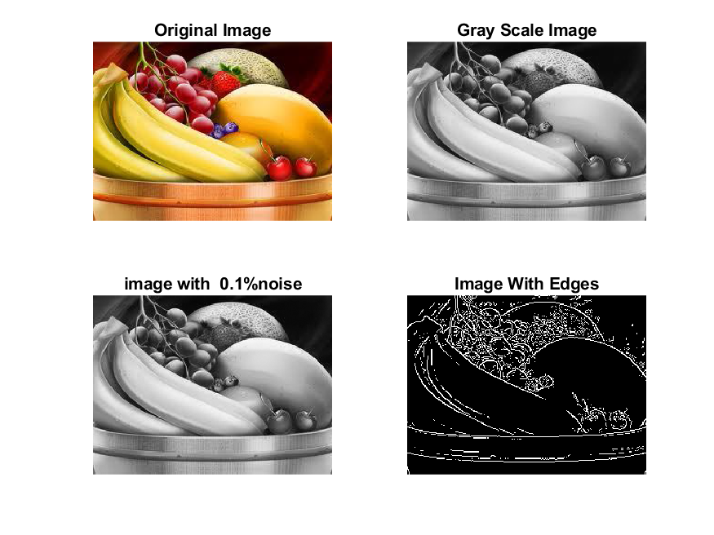

**Image 2:-10 % Noise**

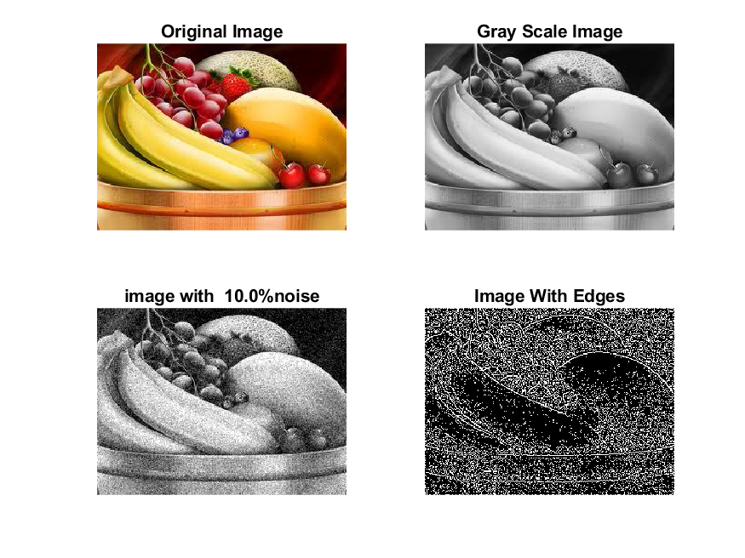

**Image 3:-20 % Noise**

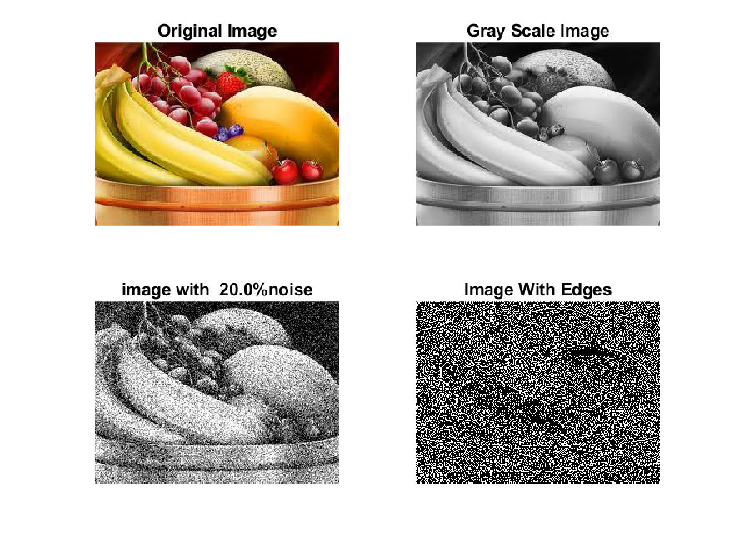

**Image 4:-30 % Noise**

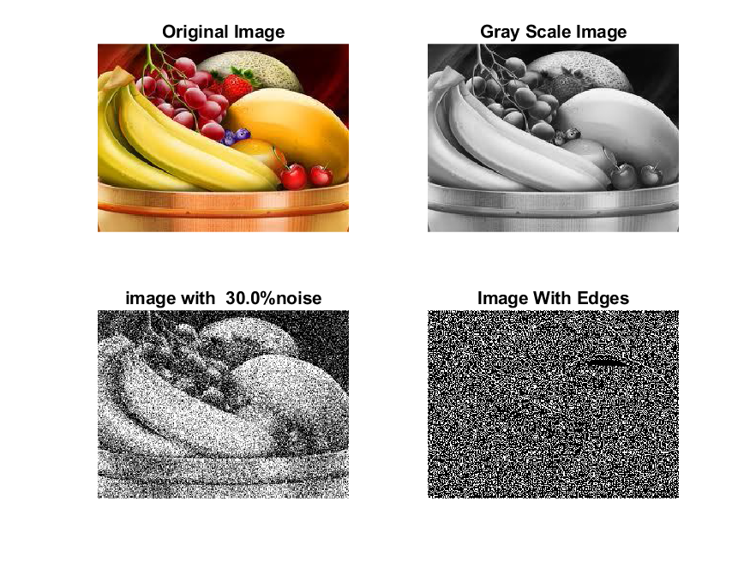

|  |
| --- |
| **Image 5:-40 % Noise** |

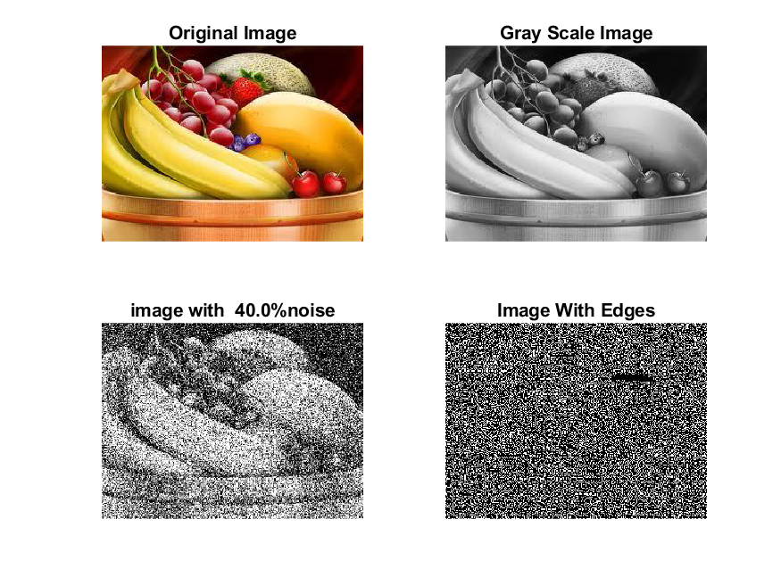

**Image 6:-50 % Noise**

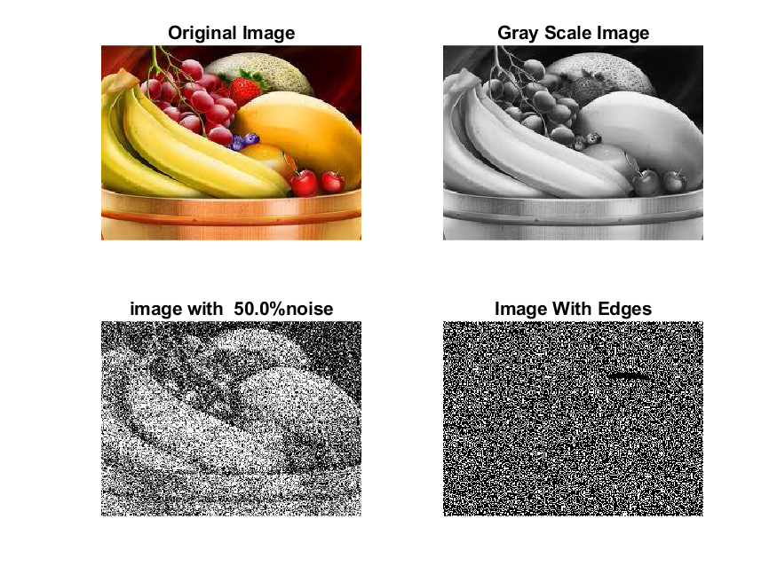

**Image 7:-60 % Noise**

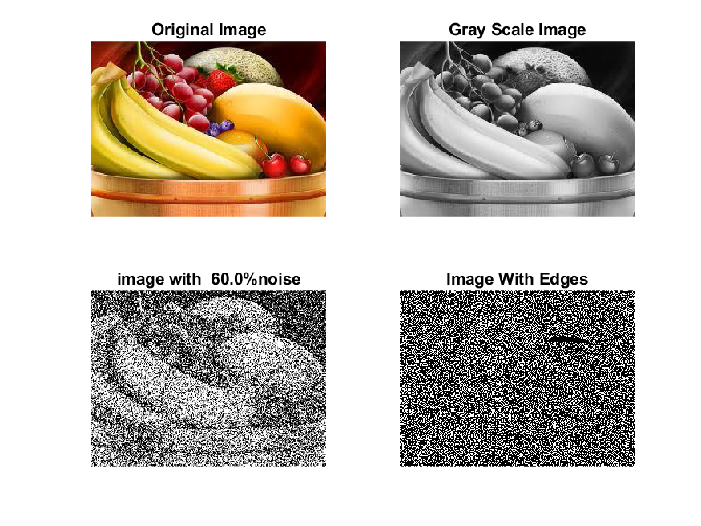

**Image 8:-70 % Noise**

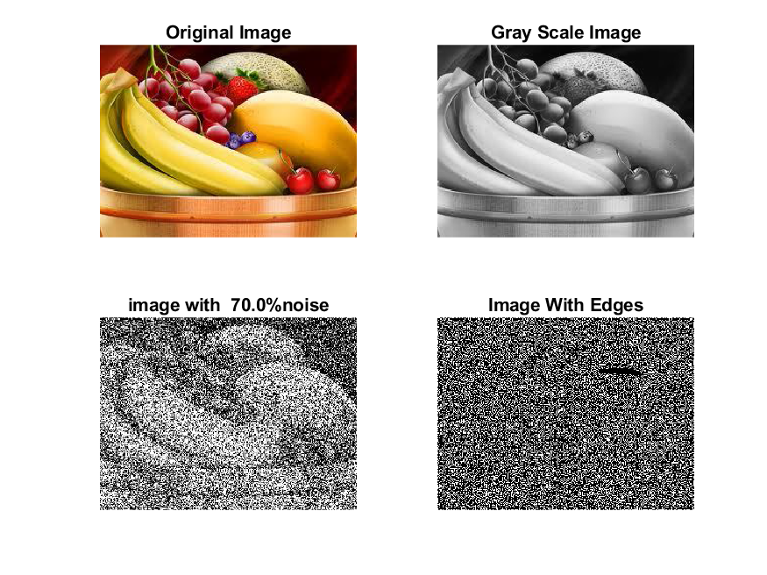

**Image 9:-80 % Noise**

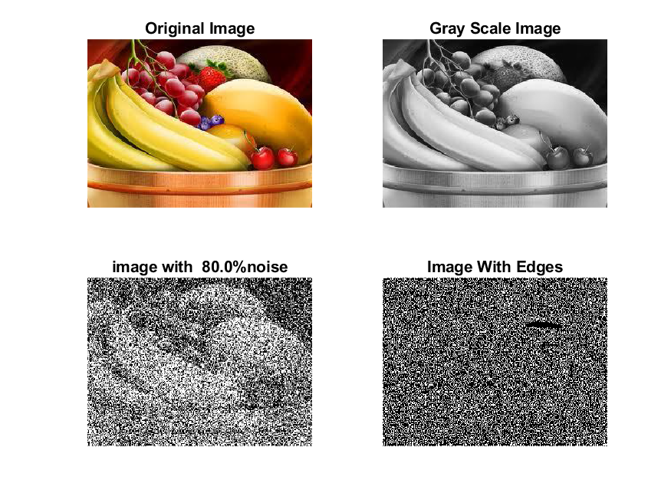

**DATA FILES**

**Image 1:-Noise0.1**

Original image ideal values:

IM1 image entropy:4.579468e-01

IM1 image mean:0.096545

Ground truth image entropy:0.815119

Ground truth image mean:0.252438

entropy between imt and im1 :0.762554

MSE between imt and im1 :0.286729

Average Difference between imt and im1 :0.155893

Maximum Difference between imt and im1 :1.000000

True Positive values:1564.000000

False Positive values: 3287.000000

True Negative values:34275.000000

False Negative values:11120.000000

Accuracy value: 0.713271

F Measure values:0.178386

Peak Signal-to Noise Ration value: 5.425279

Signal-to Noise Ration value: -4.174250

percentage of pixels that were correctly detected (Pco): 0.123305

The percentage of pixels that were not detected (Pnd):0.876695

the percentage of false alarm: (Pfa):0.259145

Euclidean Distance Value :11.401367

**Image 2:-Noise10**

Original image ideal values:

IM1 image entropy:8.158667e-01

IM1 image mean:0.252916

Ground truth image entropy:0.815119

Ground truth image mean:0.252438

entropy between imt and im1 :0.689508

MSE between imt and im1 :0.369184

Average Difference between imt and im1 :-0.000478

Maximum Difference between imt and im1 :1.000000

True Positive values:3421.000000

False Positive values: 9287.000000

True Negative values:28275.000000

False Negative values:9263.000000

Accuracy value: 0.630816

F Measure values:0.269455

Peak Signal-to Noise Ration value: 4.327576

Signal-to Noise Ration value: 0.008210

percentage of pixels that were correctly detected (Pco): 0.269201

The percentage of pixels that were not detected (Pnd):0.728911

the percentage of false alarm: (Pfa):0.730799

Euclidean Distance Value :25.958031

**Image 3:-Noise20**

Original image ideal values:

IM1 image entropy:9.048630e-01

IM1 image mean:0.320443

Ground truth image entropy:0.815119

Ground truth image mean:0.252438

entropy between imt and im1 :0.658441

MSE between imt and im1 :0.408649

Average Difference between imt and im1 :-0.068005

Maximum Difference between imt and im1 :1.000000

True Positive values:4126.000000

False Positive values: 11975.000000

True Negative values:25587.000000

False Negative values:8558.000000

Accuracy value: 0.591351

F Measure values:0.286677

Peak Signal-to Noise Ration value: 3.886491

Signal-to Noise Ration value: 1.035966

percentage of pixels that were correctly detected (Pco): 0.256257

The percentage of pixels that were not detected (Pnd):0.531520

the percentage of false alarm: (Pfa):0.743743

Euclidean Distance Value :24.659560

**Image 4:-Noise30**

Original image ideal values:

IM1 image entropy:9.123194e-01

IM1 image mean:0.327469

Ground truth image entropy:0.815119

Ground truth image mean:0.252438

entropy between imt and im1 :0.655523

MSE between imt and im1 :0.413127

Average Difference between imt and im1 :-0.075031

Maximum Difference between imt and im1 :1.000000

True Positive values:4190.000000

False Positive values: 12264.000000

True Negative values:25298.000000

False Negative values:8494.000000

Accuracy value: 0.586873

F Measure values:0.287597

Peak Signal-to Noise Ration value: 3.839160

Signal-to Noise Ration value: 1.130153

percentage of pixels that were correctly detected (Pco): 0.254649

The percentage of pixels that were not detected (Pnd):0.516227

the percentage of false alarm: (Pfa):0.745351

Euclidean Distance Value :24.498589

**Image 5:-Noise40**

Original image ideal values:

IM1 image entropy:9.189776e-01

IM1 image mean:0.334017

Ground truth image entropy:0.815119

Ground truth image mean:0.252438

entropy between imt and im1 :0.653048

MSE between imt and im1 :0.417526

Average Difference between imt and im1 :-0.081579

Maximum Difference between imt and im1 :1.000000

True Positive values:4244.000000

False Positive values: 12539.000000

True Negative values:25023.000000

False Negative values:8440.000000

Accuracy value: 0.582474

F Measure values:0.288051

Peak Signal-to Noise Ration value: 3.793167

Signal-to Noise Ration value: 1.216134

percentage of pixels that were correctly detected (Pco): 0.252875

The percentage of pixels that were not detected (Pnd):0.502890

the percentage of false alarm: (Pfa):0.747125

Euclidean Distance Value :24.321077

**Image 6:-Noise50**

Original image ideal values:

IM1 image entropy:9.225219e-01

IM1 image mean:0.337619

Ground truth image entropy:0.815119

Ground truth image mean:0.252438

entropy between imt and im1 :0.654150

MSE between imt and im1 :0.422083

Average Difference between imt and im1 :-0.085181

Maximum Difference between imt and im1 :1.000000

True Positive values:4220.000000

False Positive values: 12744.000000

True Negative values:24818.000000

False Negative values:8464.000000

Accuracy value: 0.577917

F Measure values:0.284674

Peak Signal-to Noise Ration value: 3.746018

Signal-to Noise Ration value: 1.262720

percentage of pixels that were correctly detected (Pco): 0.248762

The percentage of pixels that were not detected (Pnd):0.498939

the percentage of false alarm: (Pfa):0.751238

Euclidean Distance Value :23.910394

**Image 7:-Noise60**

Original image ideal values:

IM1 image entropy:9.252819e-01

IM1 image mean:0.340485

Ground truth image entropy:0.815119

Ground truth image mean:0.252438

entropy between imt and im1 :0.647923

MSE between imt and im1 :0.419576

Average Difference between imt and im1 :-0.088047

Maximum Difference between imt and im1 :1.000000

True Positive values:4355.000000

False Positive values: 12753.000000

True Negative values:24809.000000

False Negative values:8329.000000

Accuracy value: 0.580424

F Measure values:0.292360

Peak Signal-to Noise Ration value: 3.771897

Signal-to Noise Ration value: 1.299430

percentage of pixels that were correctly detected (Pco): 0.254559

The percentage of pixels that were not detected (Pnd):0.486848

the percentage of false alarm: (Pfa):0.745441

Euclidean Distance Value :24.488787

**Image 8:-Noise70**

Original image ideal values:

IM1 image entropy:9.254337e-01

IM1 image mean:0.340644

Ground truth image entropy:0.815119

Ground truth image mean:0.252438

entropy between imt and im1 :0.647506

MSE between imt and im1 :0.419377

Average Difference between imt and im1 :-0.088206

Maximum Difference between imt and im1 :1.000000

True Positive values:4364.000000

False Positive values: 12752.000000

True Negative values:24810.000000

False Negative values:8320.000000

Accuracy value: 0.580623

F Measure values:0.292886

Peak Signal-to Noise Ration value: 3.773957

Signal-to Noise Ration value: 1.301460

percentage of pixels that were correctly detected (Pco): 0.254966

The percentage of pixels that were not detected (Pnd):0.486095

the percentage of false alarm: (Pfa):0.745034

Euclidean Distance Value :24.529384

**Image 9:-Noise80**

Original image ideal values:

IM1 image entropy:9.287132e-01

IM1 image mean:0.344127

Ground truth image entropy:0.815119

Ground truth image mean:0.252438

entropy between imt and im1 :0.646576

MSE between imt and im1 :0.422063

Average Difference between imt and im1 :-0.091689

Maximum Difference between imt and im1 :1.000000

True Positive values:4384.000000

False Positive values: 12907.000000

True Negative values:24655.000000

False Negative values:8300.000000

Accuracy value: 0.577937

F Measure values:0.292510

Peak Signal-to Noise Ration value: 3.746223

Signal-to Noise Ration value: 1.345639

percentage of pixels that were correctly detected (Pco): 0.253542

The percentage of pixels that were not detected (Pnd):0.480019

the percentage of false alarm: (Pfa):0.746458

Euclidean Distance Value :24.387076